Week 8 Term 1 2019

**This Weekend -23rd/24th March**

Normal Training All Squads

**Next Weekend – 30th/31st March**

Normal Training All Squads

**Following Weekend – 6th/7th April BGA Testing Day**

Saturday - Normal Training All Squads

Sunday

Level 4 & 5 (Squads E,F,G,H) – 11am

Level 3 & Level 6 (Squads C,D,I,J) – 1:30pm

Level 1 & 2 (Squads K,L,M) – 4pm

**Gymnast Achievements**

Congratulations to all our Level 8 and up gymnasts who have now Qualified for the NSW Senior State Championships down in Sydney in mid April. The Level 8’s all had a great comp, with no falls! Chailend PB’d on her layout Tsukahara scoring a massive 14 and taking out the Level 9 competition once again! Aph competed her new combination on bars, Jas hit her back tuck on beam and Edan had another solid round of competiton taking out 3rd place in Level 10.

Best of luck with your preparations.

It’s been exciting to see loads of new skills and achievements from the girls these past few weeks. We have an ACHIEVEMENTS white board near the entry of the gym where the girls write up new skills or physical prep achievement, which are then displayed on our Facebook and Instagram page. Check these out and support our girls with your congratulations.

**BGA Testing Day**

At the end of term 1 (Sunday 7th April), all Level 1-6 gymnasts will participate in the BGA Testing Day, completing assessments on apparatus skills and also their first Physical Preparation Testing for the Year. This event determines what Level each gymnast will be competing in the first half on 2019, and also gives the girls an indication of how they’re doing on their Strength and Flexibility. It is a relaxed day and parents are welcome to stay and watch. Gymnasts will need to wear their current BGA Club leotard, and for those in Level 1 and 2 new to the Squad Program, the girls will need the plain purple leotard (as worn in Regional Levels), which is available for purchase from the office. Hair must be worn in the BGA comp style (please see below). Uniforms will be available on the day for gymnasts to try on and order (after their sessions) for their upcoming competition season.

Session Times:

**BGA Uniform Requirements**

Level 1 and 2 -

* Plain Purple BGA short sleeve leotard,
* Purple, navy or white BGA shirt,
* Black leggings, BGA hoodie

Level 3, 4,5,6 –

* BGA Milano Short sleeve competition leotard
* BGA Adidas Tracksuit
* BGA White Competition Team shirt
* BGA back pack
* BGA long sleeve Milano Leotard (Level 6 only)

**BGA COMP HAIR STYLE – Ponytail, plaits, tucked under**

STEP 1: Comb gel through wet hair into a mid/high ponytail. Use tight, strong hair elastics that will hold firm

STEP 2: Divide hair into 4-8 sections (dependent on thickness)

STEP 3: Run gel through and then tightly plait each section to the end, and fasten with clear small hair elastic

STEP 4: Join plaits at end with an additional hair elastic

STEP 5: Tuck joined plaits under and fasten with a strong tight hair elastic. You can bobby pin the combined ends to the hair under the ponytail.

STEP 6: Add BGA comp scrunchie

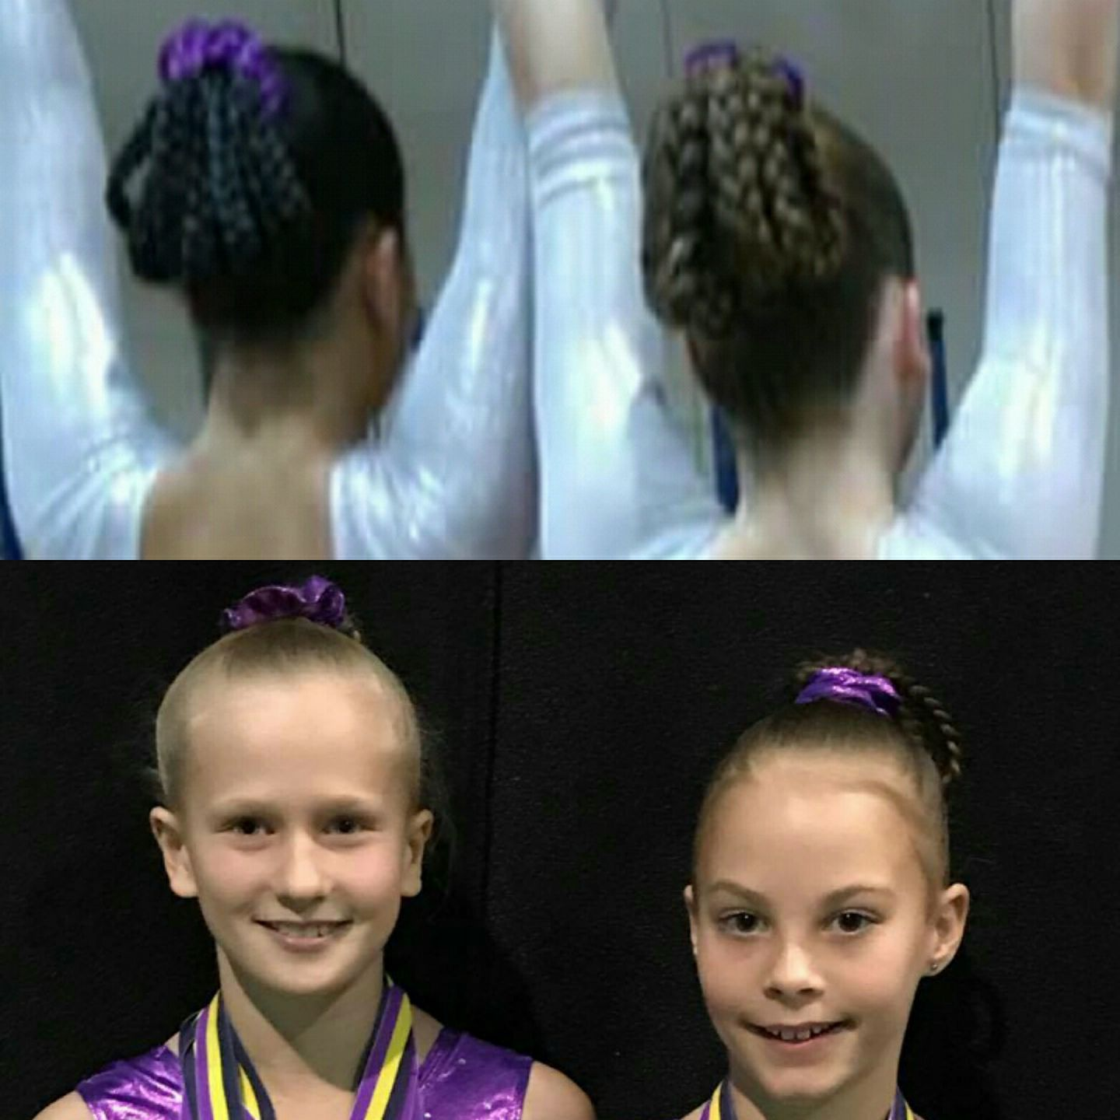

|  |  |  |  |  |  |
| --- | --- | --- | --- | --- | --- |
|  |  | BGA COMPETITION AND EVENTS CALENDAR 2019 | | | |
|  |  |  |  |  |  |
|  | SATURDAY | SUNDAY | Event | Who | Where |
|  | ~~2-Feb~~ | ~~3-Feb~~ |  |  |  |
| **T** | ~~9-Feb~~ | ~~10-Feb~~ | ~~GNSW Awards / HP Squad Clinic 1 - Snr~~ | ~~Snr~~ | ~~SGAC~~ |
| **E** | ~~16-Feb~~ | ~~17-Feb~~ | ~~BGA Invitational Pre Season~~ | ~~L7-10~~ | ~~BGA~~ |
| **R** | ~~23-Feb~~ | ~~24-Feb~~ |  |  |  |
| **M** | ~~2-Mar~~ | ~~3-Mar~~ | ~~Level 8-10/Snr Trial 1~~ | ~~8-10/Snr~~ | ~~SGAC~~ |
|  | ~~9-Mar~~ | ~~10-Mar~~ |  |  |  |
| **O** | ~~16-Mar~~ | ~~17-Mar~~ | ~~Level 8-10/Snr Trial 2~~ | ~~8-10/Snr~~ | ~~SGAC~~ |
| **N** | 23-Mar | 24-Mar |  |  |  |
| **E** | 30-Mar | 31-Mar |  |  |  |
|  | 6-Apr | 7-Apr | BGA Testing Day | Level 1-6 | BGA |
|  | 13-Apr | 14-Apr | Senior NSW State | 8-10/Snr | SGAC |
|  | 20-Apr | 21-Apr | EASTER |  |  |
|  | 27-Apr | 28-Apr | Border Challenge Trial | Level 7 | SGAC |
| **T** | 4-May | 5-May | NSW State Team Training | State Reps | SGAC |
| **E** | 11-May | 12-May | Mothers Day BGA Invitational | Level 3-7 |  |
| **R** | 18-May | 19-May |  |  |  |
| **M** | 25-May | 26-May | Aus Champs (20/5 - 26/6 TBC) | L8-10/Snr | Melbourne |
|  | 1-Jun | 2-Jun | Winter Wonderland | Level 3-7 | Manly |
| **T** | 8-Jun | 9-Jun |  |  |  |
| **W** | 15-Jun | 16-Jun | Country Capital Cup (14-16) | Level 3-10 | Tamworth |
| **O** | 22-Jun | 23-Jun |  |  |  |
|  | 29-Jun | 30-Jun | BGA Invitational | Level 1-4 | BGA |
|  | 28-Jun | 3-Jul | Border Challenge (TBC) | State Reps | QLD |
|  | 6-Jul | 7-Jul |  |  |  |
|  | 13-Jul | 14-Jul |  |  |  |
| **T** | 20-Jul | 21-Jul | Country Champs/5-7 State Qualifier (17-21) | Level 5-7+TBA | Glendale |
| **E** | 27-Jul | 28-Jul | HP Squad Clinic 2 (3 days 25-31/7) | Snr | SGAC |
| **R** | 3-Aug | 4-Aug | BGA Invitional | L5-10 | BGA |
| **M** | 10-Aug | 11-Aug |  |  |  |
|  | 17-Aug | 18-Aug | Winter State Championships | L5-7 | SGAC |
| **T** | 24-Aug | 25-Aug |  |  |  |
| **H** | 31-Aug | 1-Sep | Father's Day BGA Invitional | L1-4 | BGA |
| **R** | 7-Sep | 8-Sep |  |  |  |
| **E** | 14-Sep | 15-Sep | Auatralian Classic (15-18/9) | Int. Stream | Gold Coast |
| **E** | 21-Sep | 22-Sep | National Cubs Carnival (20-29/9) | TBA | Gold Coast |
|  | 28-Sep | 29-Sep | National Cubs Carnival (20-29/9) | TBA | Gold Coast |
|  | 5-Oct | 6-Oct |  |  |  |
|  | 12-Oct | 13-Oct |  |  |  |
| **T** | 19-Oct | 20-Oct |  |  |  |
| **E** | 26-Oct | 27-Oct |  |  |  |
| **R** | 2-Nov | 3-Nov |  |  |  |
| **M** | 9-Nov | 10-Nov |  |  |  |
|  | 16-Nov | 17-Nov |  |  |  |
| **F** | 23-Nov | 24-Nov | Senior Gymsport/ State Squad Clinic 3 | Snr/L10 |  |
| **O** | 30-Nov | 1-Dec |  |  |  |
| **U** | 7-Dec | 8-Dec |  |  |  |
| **R** | 14-Dec | 15-Dec | Xmas Cup & Display | All |  |
|  | 21-Dec | 22-Dec |  |  |  |
|  | 28-Dec | 29-Dec |  |  |  |
|  |  |  |  |  |  |
| School holidays | | GA Events | BGA Invitationals/events | GNSW Events | Optional events |

**Competition entries**

Please find above the draft competition calendar for 2019. Although some competition dates may be added or amended it will give you some idea of when and where your daughters’ competitions are likely to be held throughout the year. Level 1-7 Invitational competitions will be added in terms 2/3/4 once released by hosting clubs. It is expected that ALL gymnasts in our Competitive Levels program compete in ALL competitions that they are eligible for. We understand and can make exceptions for clashes with family events, overseas trips, exams or injury/medical conditions. In these instances it is essential that you let the administration staff, along with your child’s coach know of your unavailability at least 2 months prior to the competition. Most entries are due and are paid by the club, 6-8 weeks before the competition. Gymnasts who are entered in competitions but fail to compete will still be charged the entry fee. Acute injuries, along with provision of medical certificate can in some cases receive a partial refund.