Week 6 Term 1 2019

This Weekend -9th/10th March
Normal Training all Squads

Next Weekend – 16th/17th March - L8-10/Snr GNSW State Trial 2 SGAC
Training - Normal Training (no training for Level 8-10/Snr Sat, No training 10/Snr Fri)
Competition
Saturday Session 1 – Level 10 (Jas, Edan) – WU 11:30am Comp 1pm
Session 2 – Snr Int. (Aph) – WU 3:45pm, Comp 5:15pm
Sunday Session 2 – Level 9 Open (Chailend), Level 8 (Bella, Coco, Soph, Alex) – WU 12pm, Comp 1:30pm
Short sleeve leo for Warm up, Long Sleeve leo for comp, comp shirt and tracksuit needed.

Following Weekend – 23rd/24th March
Normal Training All Squads

Gymnast Achievements
Congratulations to all our Level 8- 10/Snr that competed at their first State Trial last weekend down in Sydney. All the girls placed individually on an apparatus, with Aphra, Edan and Chailend also placing top 3 all around. Our Level 10’s ,Edan and Jas, and our Snr International gymnast Aph, all scored the All Around total necessary to qualify for the Australian Championships in May, which confirms their place on the NSW State Team.

BGA Testing Day
At the end of term 1 (Sunday 7th April), all Level 1-6 gymnasts will participate in the BGA Testing Day, completing assessments on apparatus skills and also their first Physical Preparation Testing for the Year. This event determines what Level each gymnast will be competing in the first half on 2019, and also gives the girls an indication of how they’re doing on their Strength and Flexibility. It is a relaxed day and parents are welcome to stay and watch. Gymnasts will need to wear their current BGA Club leotard, and for those in Level 1 and 2 new to the Squad Program, the girls will need the plain purple leotard (as worn in Regional Levels), which is available for purchase from the office. Hair must be worn in the BGA comp style (please see below). Uniforms will be available on the day for gymnasts to try on and order (after their sessions) for their upcoming competition season.
Session Times:
Level 4 & 5 (Squads E,F,G,H) – 11am
Level 3 & Level 6 (Squads C,D,I,J) – 1:30pm
Level 1 & 2 (Squads K,L,M) – 4pm

BGA Uniform Requirements
Level 1 and 2 -
- Plain Purple BGA short sleeve leotard,
- Purple, navy or white BGA shirt,
- Black leggings, BGA hoodie
Level 3, 4,5,6 –
- BGA Milano Short sleeve competition leotard
- BGA Adidas Tracksuit
- BGA White Competition Team shirt
- BGA back pack
- BGA long sleeve Milano Leotard (Level 6 only)

BGA COMP HAIR STYLE – Ponytail, plaits, tucked under
STEP 1: Comb gel through wet hair into a mid/high ponytail. Use tight, strong hair elastics that will hold firm
STEP 2: Divide hair into 4-8 sections (dependent on thickness)
STEP 3: Run gel through and then tightly plait each section to the end, and fasten with clear small hair elastic
STEP 4: Join plaits at end with an additional hair elastic
STEP 5: Tuck joined plaits under and fasten with a strong tight hair elastic. You can bobby pin the combined ends to the hair under the ponytail.
STEP 6: Add BGA comp scrunchie
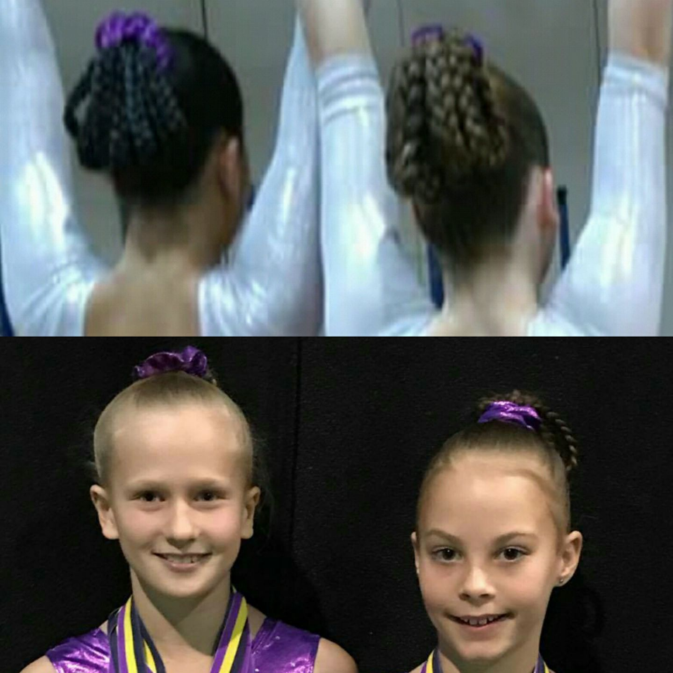
 |  | BGA COMPETITION AND EVENTS CALENDAR 2019
 | SATURDAY | SUNDAY | Event | Who | Where
 | 2-Feb | 3-Feb
T | 9-Feb | 10-Feb | GNSW Awards / HP Squad Clinic 1 - Snr | Snr | SGAC
E | 16-Feb | 17-Feb | BGA Invitational Pre Season | L7-10 | BGA
R | 23-Feb | 24-Feb
M | 2-Mar | 3-Mar | Level 8-10/Snr Trial 1 | 8-10/Snr | SGAC
 | 9-Mar | 10-Mar
O | 16-Mar | 17-Mar | Level 8-10/Snr Trial 2 | 8-10/Snr | SGAC
N | 23-Mar | 24-Mar
E | 30-Mar | 31-Mar
 | 6-Apr | 7-Apr | BGA Testing Day | Level 1-6 | BGA
 | 13-Apr | 14-Apr | Senior NSW State | 8-10/Snr | SGAC
 | 20-Apr | 21-Apr | EASTER
 | 27-Apr | 28-Apr | Border Challenge Trial | Level 7 | SGAC
T | 4-May | 5-May | NSW State Team Training | State Reps | SGAC
E | 11-May | 12-May | Mothers Day BGA Invitational | Level 3-7
R | 18-May | 19-May
M | 25-May | 26-May | Aus Champs (20/5 - 26/6 TBC) | L8-10/Snr | Melbourne
 | 1-Jun | 2-Jun | Winter Wonderland | Level 3-7 | Manly
T | 8-Jun | 9-Jun
W | 15-Jun | 16-Jun | Country Capital Cup (14-16) | Level 3-10 | Tamworth
O | 22-Jun | 23-Jun
 | 29-Jun | 30-Jun | BGA Invitational | Level 1-4 | BGA
 | 28-Jun | 3-Jul | Border Challenge (TBC) | State Reps | QLD
 | 6-Jul | 7-Jul
 | 13-Jul | 14-Jul
T | 20-Jul | 21-Jul | Country Champs/5-7 State Qualifier (17-21) | Level 5-7+TBA | Glendale
E | 27-Jul | 28-Jul | HP Squad Clinic 2 (3 days 25-31/7) | Snr | SGAC
R | 3-Aug | 4-Aug | BGA Invitional | L5-10 | BGA
M | 10-Aug | 11-Aug
 | 17-Aug | 18-Aug | Winter State Championships | L5-7 | SGAC
T | 24-Aug | 25-Aug
H | 31-Aug | 1-Sep | Father's Day BGA Invitional | L1-4 | BGA
R | 7-Sep | 8-Sep
E | 14-Sep | 15-Sep | Auatralian Classic (15-18/9) | Int. Stream | Gold Coast
E | 21-Sep | 22-Sep | National Cubs Carnival (20-29/9) | TBA | Gold Coast
 | 28-Sep | 29-Sep | National Cubs Carnival (20-29/9) | TBA | Gold Coast
 | 5-Oct | 6-Oct
 | 12-Oct | 13-Oct
T | 19-Oct | 20-Oct
E | 26-Oct | 27-Oct
R | 2-Nov | 3-Nov
M | 9-Nov | 10-Nov
 | 16-Nov | 17-Nov
F | 23-Nov | 24-Nov | Senior Gymsport/ State Squad Clinic 3 | Snr/L10
O | 30-Nov | 1-Dec
U | 7-Dec | 8-Dec
R | 14-Dec | 15-Dec | Xmas Cup & Display | All
 | 21-Dec | 22-Dec
 | 28-Dec | 29-Dec
School holidays |  | GA Events | BGA Invitationals/events | GNSW Events | Optional events

Competition entries
Please find above the draft competition calendar for 2019. Although some competition dates may be added or amended it will give you some idea of when and where your daughters’ competitions are likely to be held throughout the year. Level 1-7 Invitational competitions will be added in terms 2/3/4 once released by hosting clubs. It is expected that ALL gymnasts in our Competitive Levels program compete in ALL competitions that they are eligible for. We understand and can make exceptions for clashes with family events, overseas trips, exams or injury/medical conditions. In these instances it is essential that you let the administration staff, along with your child’s coach know of your unavailability at least 2 months prior to the competition. Most entries are due and are paid by the club, 6-8 weeks before the competition. Gymnasts who are entered in competitions but fail to compete will still be charged the entry fee. Acute injuries, along with provision of medical certificate can in some cases receive a partial refund.

