Week 10 Term 1 2019
This Weekend -6th/7th April BGA Testing Day
Normal Training All Squads
Sunday - Testing Day
Level 4 & 5 (Squads E,F,G,H) – 11am
Level 3 & Level 6 (Squads C,D,I,J) – 1:30pm
Level 1 & 2 (Squads K,L,M) – 4pm

Next Weekend – 13th/14th April Senior NSW State Championships (SGAC)
Normal Training All Squads TBC
NO training Sat Squad A, Fri 4-6pm - Level 8/9, no training 10+
Saturday
Level 10: Warm Up 8:30am Presentation 12:45pm
Snr: Warm Up 2pm, Presentation 6:20pm
Sunday
Level 8 Jnr (Bella, Alex): Warm Up 8:30am, Presentation 12:55
Level 8 Snr (Coco, Soph), Level 9: Warm Up 1:30, Presentation 5:40pm

Following Weeks –15th-28th April School Holidays Training
Squad A (L8+): Mon 1-5, Tues, 1:30-6, Thur 1-6, Sat 10-2, Tues 1-6, Wed 2-6, Fri 1:30-6, Sat 10-2
Squad B (L7 only): Mon 2-5, Tue 2-6, Wed 2-5, Thur comp (TBA), Sat 10-2, Tues 3:30-6, Wed comp TBA, Fri 3:30-6
Squad D (All L6): Mon 11:30-2:30, Wed 12:30-5, Thur 12-4:30, Tues 1:30-6, Wed 2-6, Fri 2-6
Squad E (Anita): Mon 2-5, Tue 2-6, Wed 10-2, Thur 1-4, Tue 2:30-6, Wed 2-6, Fri 3-6
Squad F (Claire/Mon): Mon 11:30-3:30, Tue 8:30-12:30, Wed 8:30-12:30, Thur 1-5, Tue 8:30-12:30, Wed 11-2, Fri 8:30-11:30
Squad G (Anita/Helen): Mon 11:30-2, Tue 11-2, Thur 3:30-6, Tue 12-3:30, Wed 11:30-2:30, Fri 1-3:30
Squad H (Monica): Mon 11:30-2, Tue 8:30-12, Thur 3:30-6, Tues 12:30-3:30, Wed 12:30-3:30, Fri 8:30-11:30
Squad I (Claire): Mon 8:30-11:30, Thur 8:30-12, Tue 12:30-3:30, Wed 8:30-11, Fri 12-3
Squad J (Monique): Week 1 Mon, Wed, Thur 8:30-11:30, Week 2 Tue, Fri 8:30-12
Squad K (Helen): Tues 11-2, Wed 10-12:30, Tue 10-12, Fri 1-3:30
Squad M (Level 1): Week 1 Mon 11-12:30, Wed 8:30-12:30, Week 2 Tues 1-2:30, Wed 12-1:30

Border Challenge Trial (Mak, Liv, Jem, Georgia, Mila) SGAC
Sun 28th April – Warm Up 12:30pm Warm Up.

Gymnastics Australia Child Safety Booklet – Bravehearts and GA have partnered in Australian first initiative to protect children engaged with gymnastics in Australia. They have provided a parent guide book for every member which includes provides vital personal safety messages for children and young people. Please collect your free copy from the front desk.

External Invitational Sign Up Sheet
As part of our competition season we are taking the girls to a number of Invitationals at other venues. We will have a spread sheet posted near the office for you to fill in. If you could please confirm your child’s availability for each competition, to allow us to the correct entries when needed (before end of Term 1, 13th April for Manly/Tamworth). We have added three more Invitationals likely to occur later in the year for our lower levels (1-3), at Kimnastix and Central Coast Gymnastics Academy (both on the Central Coast) and Icon Gymsports (Hornsby, Sydney). Please see the updated calendar for dates.

Perth Invitational
We are looking for expression of interest from our Level 8-10/Snr gymnasts to attend the Perth International Competition held on July 20th/21st. Gymnasts will organise own travel and accommodation, though we can look after a gymnast if parents are unable to attend. Please see Karen for more information.

BGA Testing Day
At the end of term 1 (Sunday 7th April), all Level 1-6 gymnasts will participate in the BGA Testing Day, completing assessments on apparatus skills and also their first Physical Preparation Testing for the Year. This event determines what Level each gymnast will be competing in the first half on 2019, and also gives the girls an indication of how they’re doing on their Strength and Flexibility. It is a relaxed day and parents are welcome to stay and watch. Gymnasts will need to wear their current BGA Club leotard, and for those in Level 1 and 2 new to the Squad Program, the girls will need the plain purple leotard (as worn in Regional Levels), which is available for purchase from the office. Hair must be worn in the BGA comp style (please see below). Uniforms will be available on the day for gymnasts to try on and order (after their sessions) for their upcoming competition season.

BGA COMP HAIR STYLE – Ponytail, plaits, tucked under
STEP 1: Comb gel through wet hair into a mid/high ponytail. Use tight, strong hair elastics that will hold firm
STEP 2: Divide hair into 4-8 sections (dependent on thickness)
STEP 3: Run gel through and then tightly plait each section to the end, and fasten with clear small hair elastic
STEP 4: Join plaits at end with an additional hair elastic
STEP 5: Tuck joined plaits under and fasten with a strong tight hair elastic. You can bobby pin the combined ends to the hair under the ponytail.
STEP 6: Add BGA competition Scrunchie

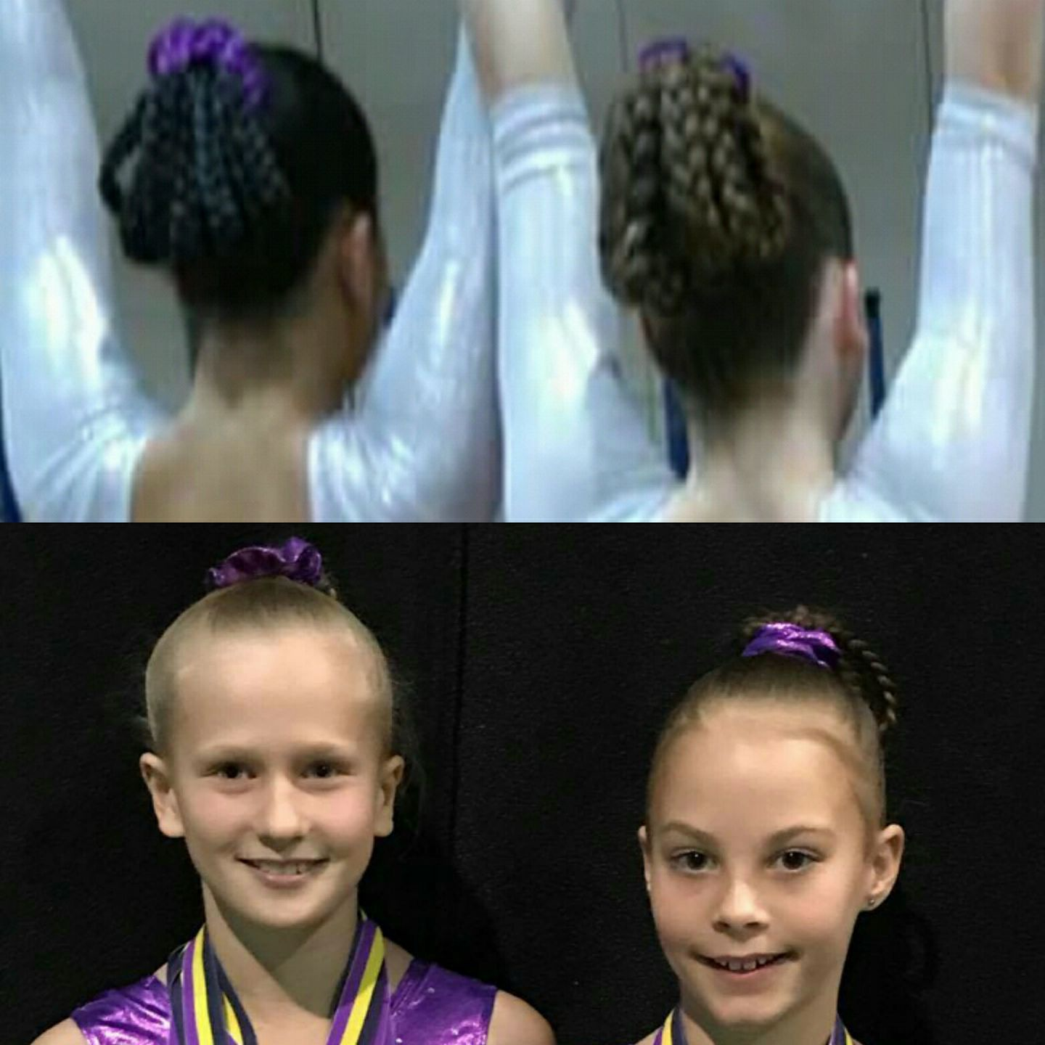

 |  | BGA COMPETITION AND EVENTS CALENDAR 2019
 | SATURDAY | SUNDAY | Event | Who | Where
 | 2-Feb | 3-Feb
T | 9-Feb | 10-Feb | GNSW Awards / HP Squad Clinic 1 - Snr | Snr | SGAC
E | 16-Feb | 17-Feb | BGA Invitational Pre Season | L7-10 | BGA
R | 23-Feb | 24-Feb
M | 2-Mar | 3-Mar | Level 8-10/Snr Trial 1 | 8-10/Snr | SGAC
 | 9-Mar | 10-Mar
O | 16-Mar | 17-Mar | Level 8-10/Snr Trial 2 | 8-10/Snr | SGAC
N | 23-Mar | 24-Mar
E | 30-Mar | 31-Mar
 | 6-Apr | 7-Apr | BGA Testing Day | Level 1-6 | BGA
 | 13-Apr | 14-Apr | Senior NSW State | 8-10/Snr | SGAC
 | 20-Apr | 21-Apr | EASTER
 | 27-Apr | 28-Apr | Border Challenge Trial | Level 7 | SGAC
T | 4-May | 5-May | NSW State Team Training | State Reps | SGAC
E | 11-May | 12-May | Mothers Day BGA Invitational | Level 3-7
R | 18-May | 19-May
M | 25-May | 26-May | Aus Champs (20/5 - 26/6) | L8-10/Snr | Melbourne
 | 1-Jun | 2-Jun | Winter Wonderland | Level 3-7 | Manly
T | 8-Jun | 9-Jun
W | 15-Jun | 16-Jun | Country Capital Cup (14-16) | Level 3-10 | Tamworth
O | 22-Jun | 23-Jun
 | 29-Jun | 30-Jun | BGA Invitational | Level 1-4 | BGA
 | 28-Jun | 3-Jul | Border Challenge (TBC) | State Reps | QLD
 | 6-Jul | 7-Jul | Central Coast Invitational | Level 1-3 (TBC) | Central Coast
 | 13-Jul | 14-Jul
T | 20-Jul | 21-Jul | Country Champs/5-7 State Qualifier (17-21)? Perth International | Level 5-7+TBA | Glendale
E | 27-Jul | 28-Jul | HP Squad Clinic 2 (3 days 25-31/7) | Snr | SGAC
R | 3-Aug | 4-Aug | BGA Invitional | L5-10 | BGA
M | 10-Aug | 11-Aug | Kimnastix Invitational | Level 1-3 (TBC) | Tuggerah
 | 17-Aug | 18-Aug | Winter State Championships | L5-7 | SGAC
T | 24-Aug | 25-Aug
H | 31-Aug | 1-Sep | Father's Day BGA Invitional | L1-4 | BGA
R | 7-Sep | 8-Sep | Icon Invitational | L1/2 | Hornsby
E | 14-Sep | 15-Sep | Auatralian Classic (15-18/9) | Int. Stream | Gold Coast
E | 21-Sep | 22-Sep | National Cubs Carnival (20-29/9) | TBA | Gold Coast
 | 28-Sep | 29-Sep | National Cubs Carnival (20-29/9) | TBA | Gold Coast
 | 5-Oct | 6-Oct
 | 12-Oct | 13-Oct
T | 19-Oct | 20-Oct
E | 26-Oct | 27-Oct
R | 2-Nov | 3-Nov
M | 9-Nov | 10-Nov
 | 16-Nov | 17-Nov
F | 23-Nov | 24-Nov | Senior Gymsport/ State Squad Clinic 3 | Snr/L10
O | 30-Nov | 1-Dec
U | 7-Dec | 8-Dec
R | 14-Dec | 15-Dec | Xmas Cup & Display | All
 | 21-Dec | 22-Dec
 | 28-Dec | 29-Dec
School holidays |  | GA Events | BGA Invitationals/events | GNSW Events | Optional events

Competition entries
Please find above the draft competition calendar for 2019. Although some competition dates may be added or amended it will give you some idea of when and where your daughters’ competitions are likely to be held throughout the year. Level 1-7 Invitational competitions will be added in terms 2/3/4 once released by hosting clubs. It is expected that ALL gymnasts in our Competitive Levels program compete in ALL competitions that they are eligible for. We understand and can make exceptions for clashes with family events, overseas trips, exams or injury/medical conditions. In these instances it is essential that you let the administration staff, along with your child’s coach know of your unavailability at least 2 months prior to the competition. Most entries are due and are paid by the club, 6-8 weeks before the competition. Gymnasts who are entered in competitions but fail to compete will still be charged the entry fee. Acute injuries, along with provision of medical certificate can in some cases receive a partial refund.

